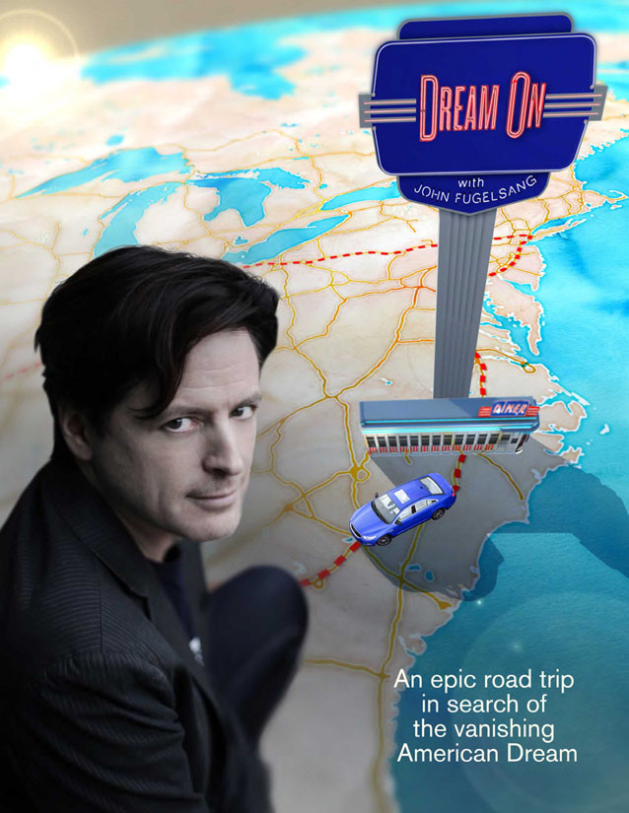

DREAM ON features political comedian John Fugelsang as he hits the road in search of the vanishing American Dream after decades of rising income inequality and declining economic mobility.

Please join us for a screening of this new documentary
at ___________________

Date___, Time___, Place____
Panel discussion with_________after screening

[Contact information to RSVP]

For more information about the film, please go to http://pppdocs.com/dreamon.html

